**Project Name: VALIDATION OF USER LOGIN**

**Developer Name:** Kapil Davey

**GitHub Link:-** [**https://github.com/kapildavey/Phase-2.git**](https://github.com/kapildavey/Phase-2.git)

**Output:-**

**LogIn:-**

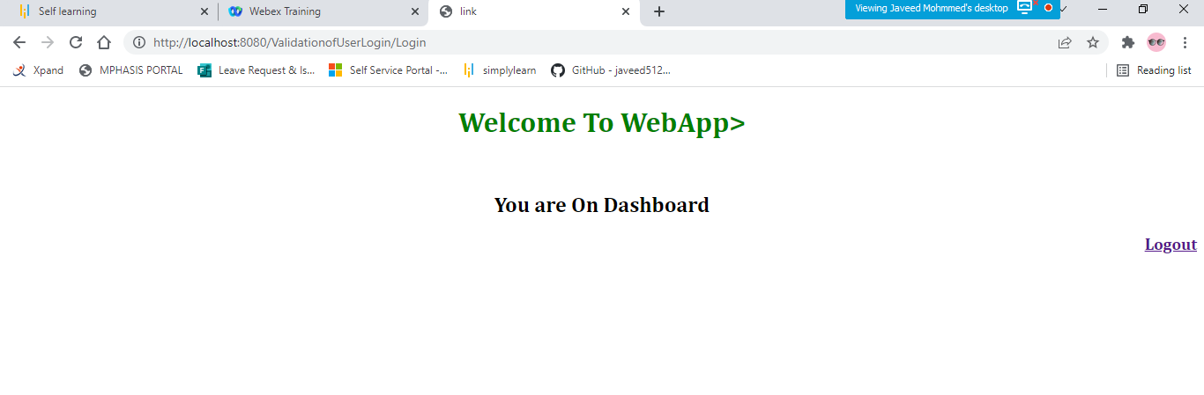

**logout:-**

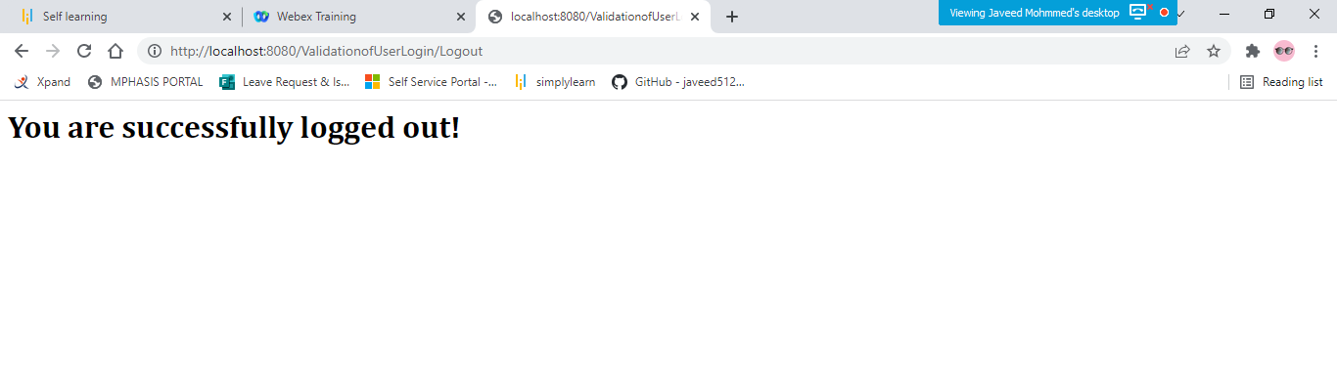

**Invalid Username and Password:-**

